1. Create Weber bot ,please refer Weber Bot creation steps
2. Install MongoDB ,create required collections and insert documents ,please refer Mongo DB and collection creation steps
3. Install java (jdk1.8) ,tomcat v8 and eclipse
4. Import webexbot source code

<https://gitscm.cisco.com/projects/IT-CVC-CISCOCOMMERCE-CCWDIRECT/repos/webexbot/browse>

1. Change DBNAME, USERNAME and PASSWORD property values in mongo.local.properties
2. Run maven build
3. Open server.xml and add context inside host element <host> </host>

<Context docBase="C:\Users\XXXX\git\WebExCbot\target\WebExBot" path="/web"

reloadable="true" workDir="C:\XXXX\golreddy\git\WebExCbot\work"/>

1. Open tomcat-users.xml and add user inside tomcat-users element

<tomcat-users>

<user username="Venkat" password="" roles="user"/>

</tomcat-users>

1. Create Webhook configuration to receive messages ,please refer Webhook configuration steps
2. Start your tomcat server and hit <http://localhost:8080/web/chatbot>

a) Enter username , password and click on sign in

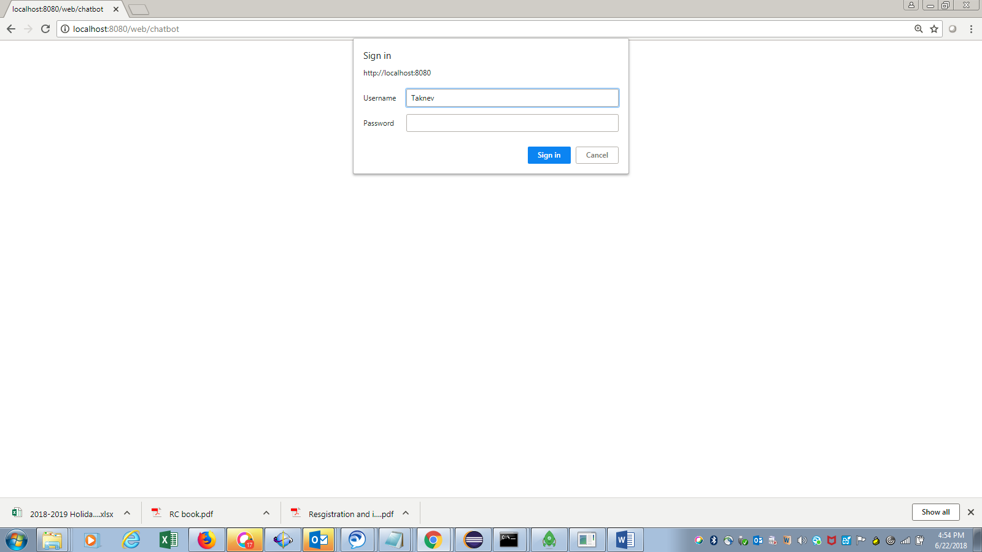

b) Click on chat icon at bottom

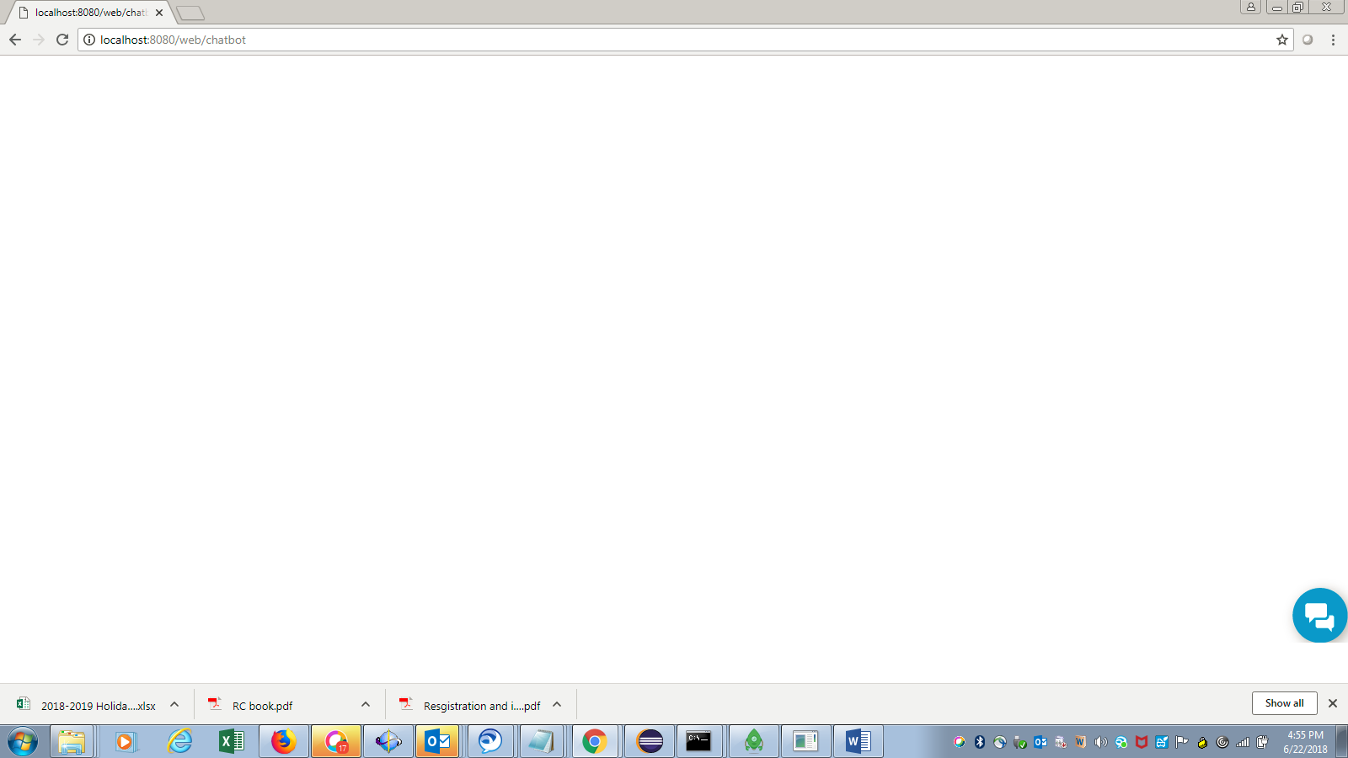

You can see welcome message

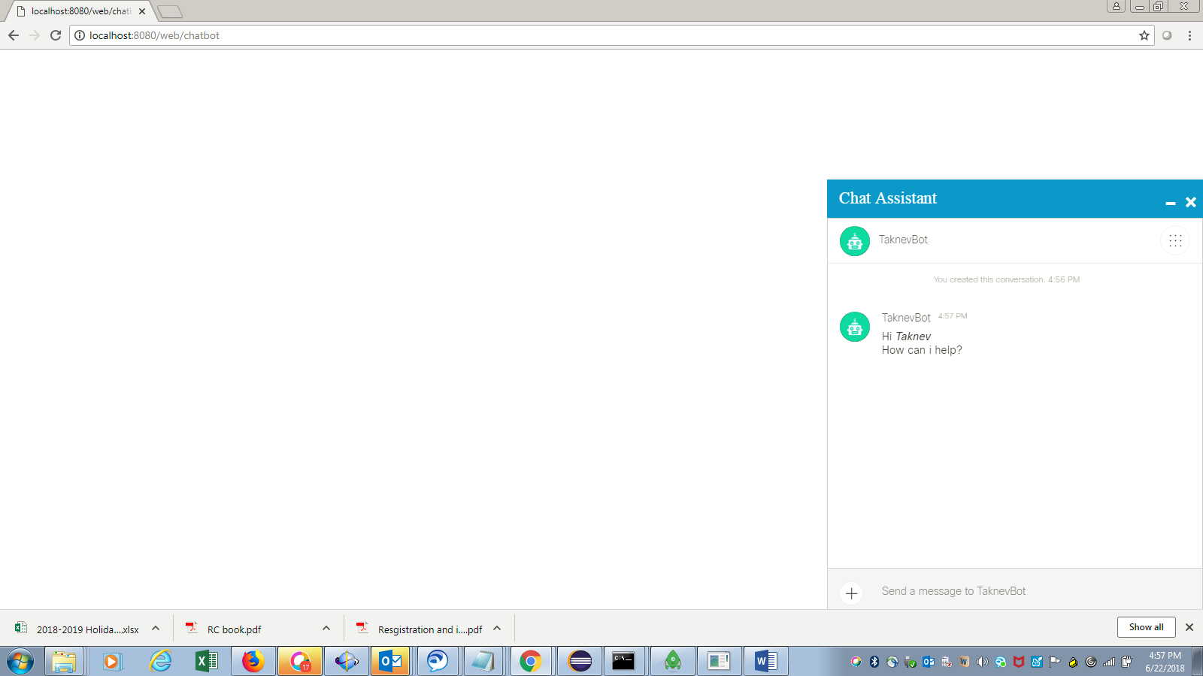

c) Type ‘Hi’ then you will get response from bot

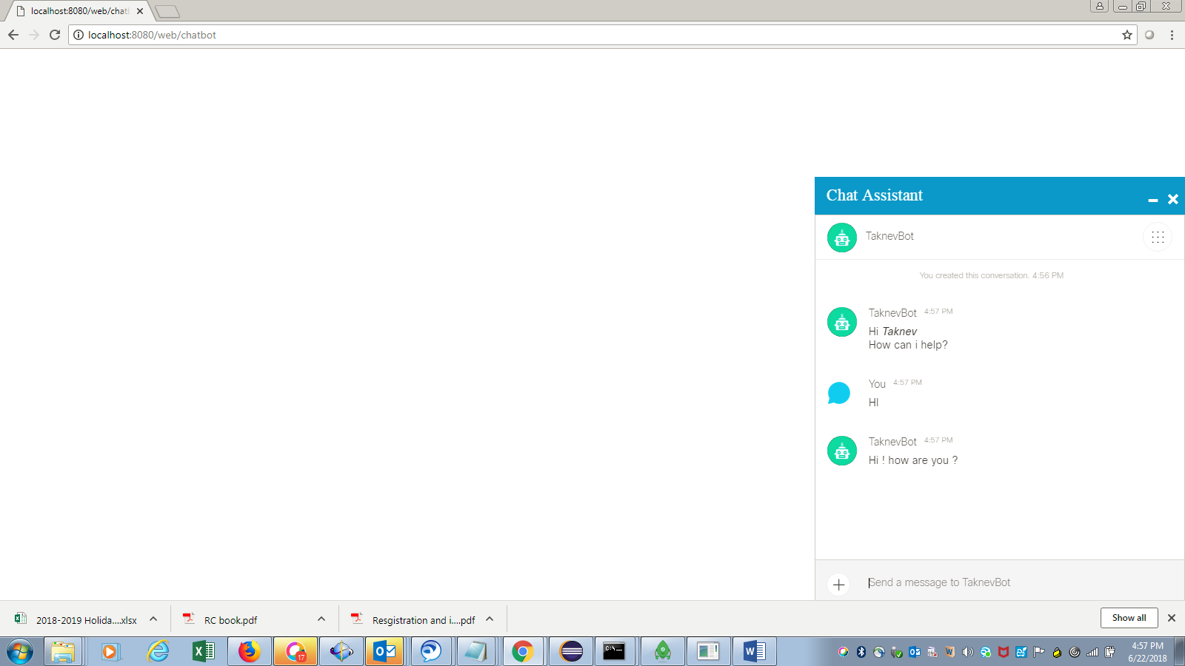

d) If you want to connect support agent, type agent then bot will be removed and agent will be added.

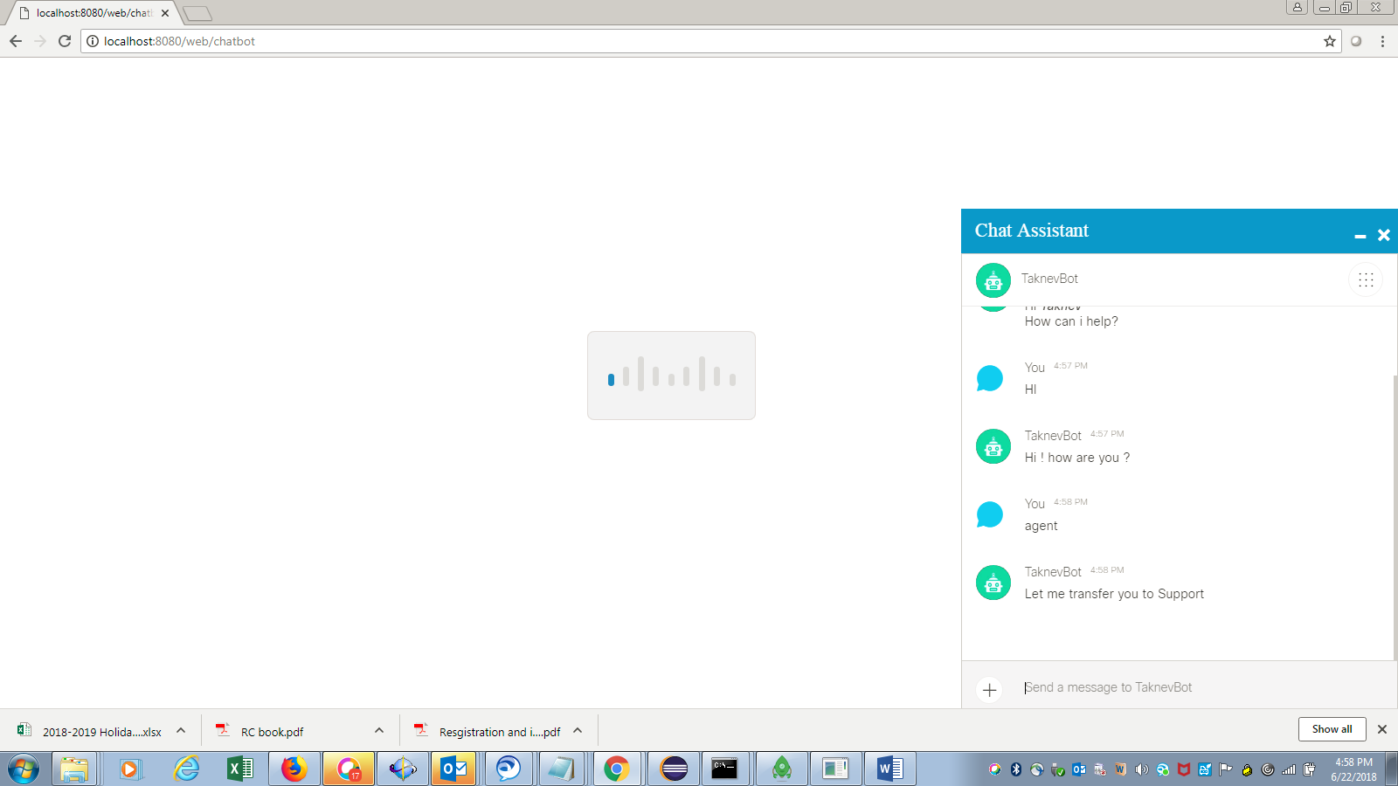

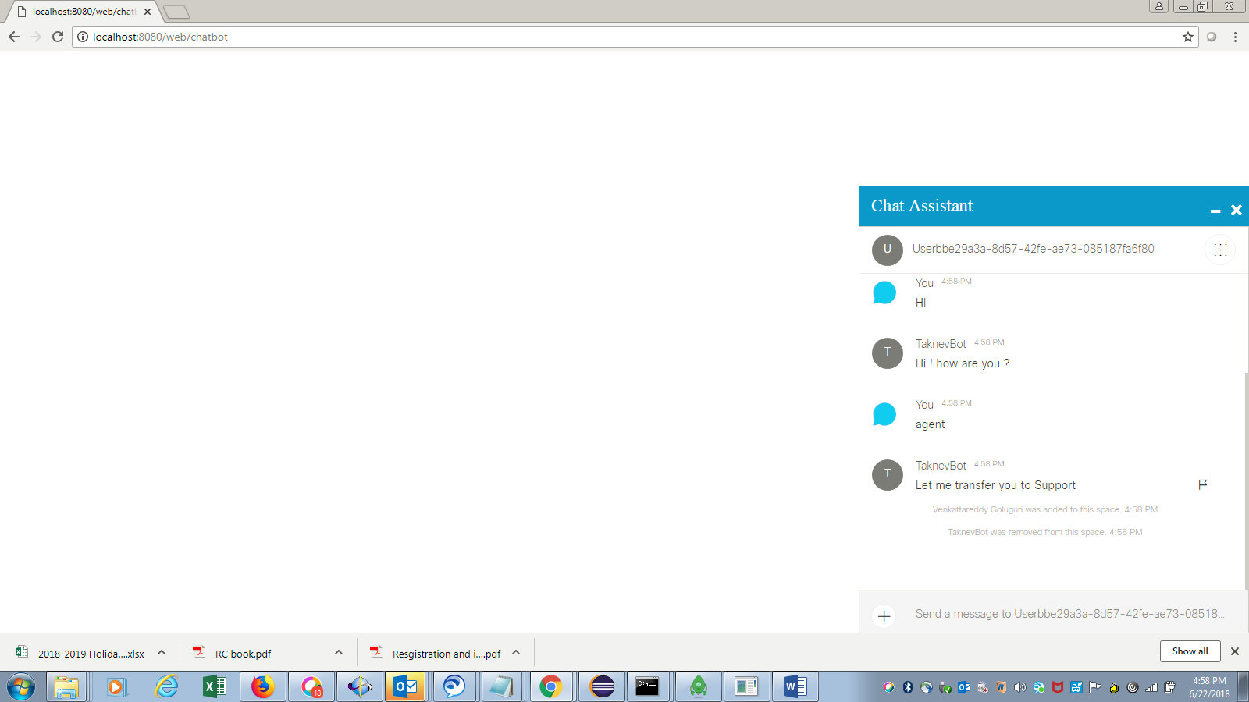

We can drag chat assistant section anywhere in the page, we can minimize and also we can close it.